RNN

**Reference: (Important)**

* <http://karpathy.github.io/>
* [**http://colah.github.io/posts/2015-08-Understanding-LSTMs/**](http://colah.github.io/posts/2015-08-Understanding-LSTMs/)
* https://arxiv.org/abs/1506.02078

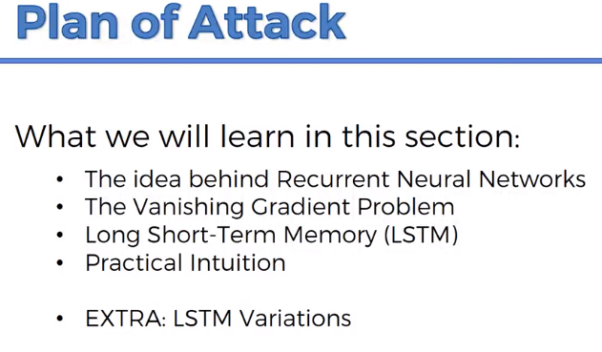



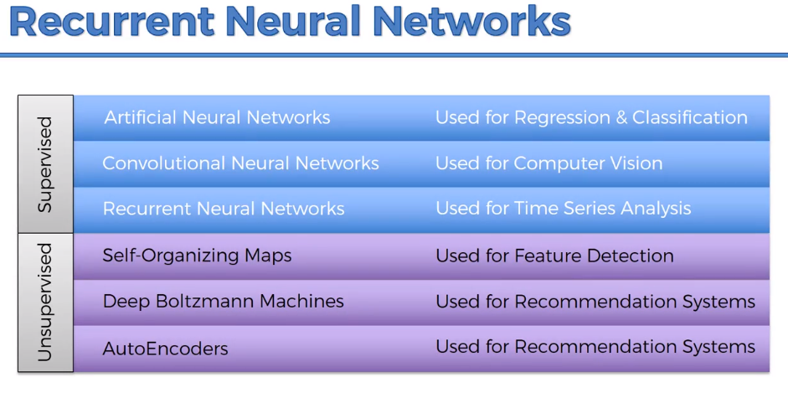

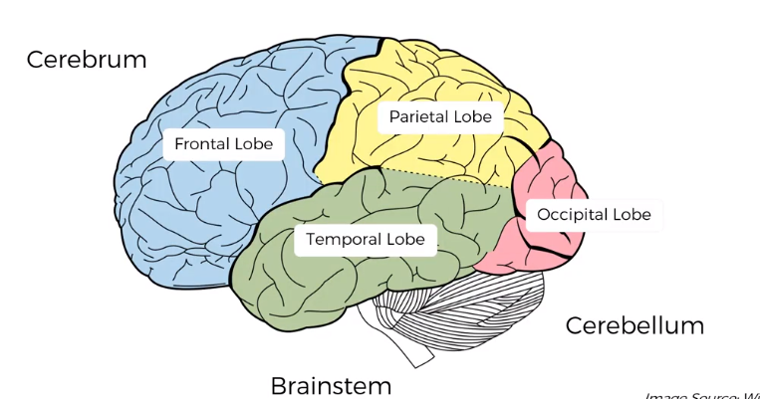

* Temporal Lobe🡪Long Term memory🡪 ANN
* Occipital Lobe🡪 Computer Vision🡪 CNN
* Frontal Lobe🡪 Short term memory🡪 RNN

**Step 1:**

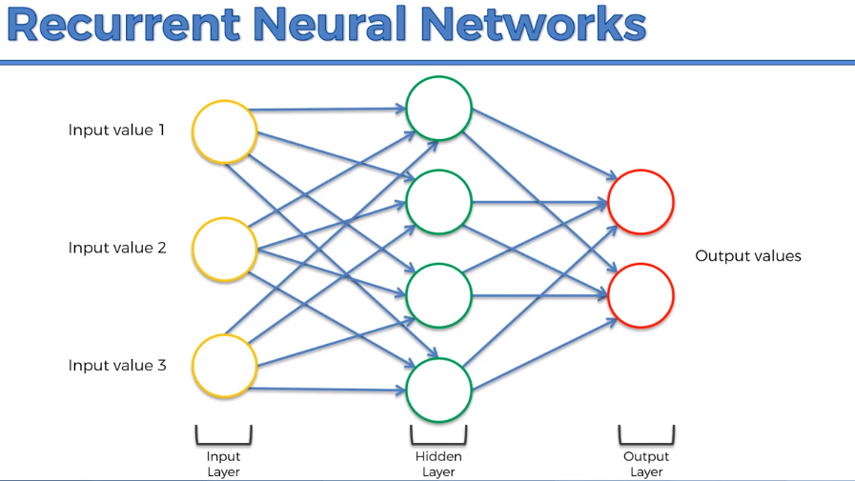

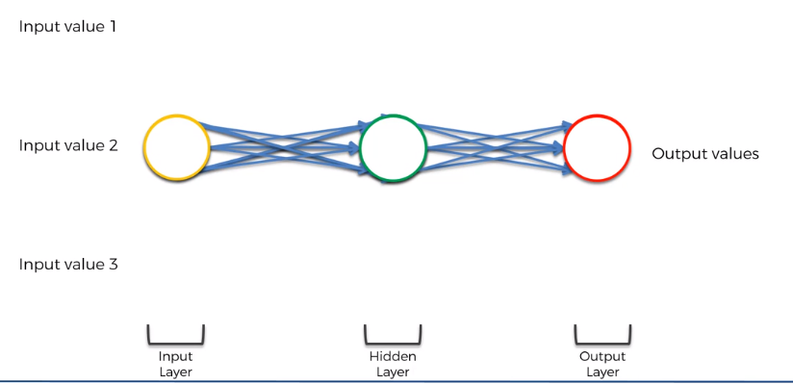

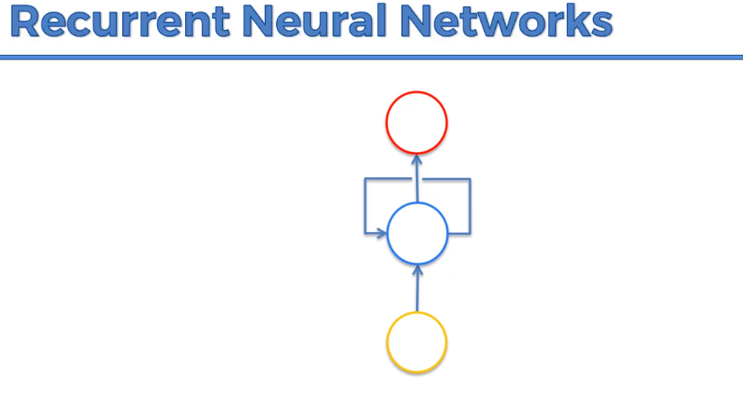

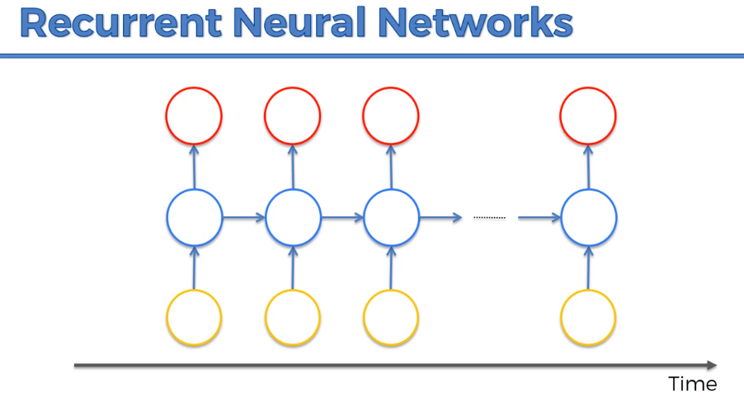

Layer of neurons:

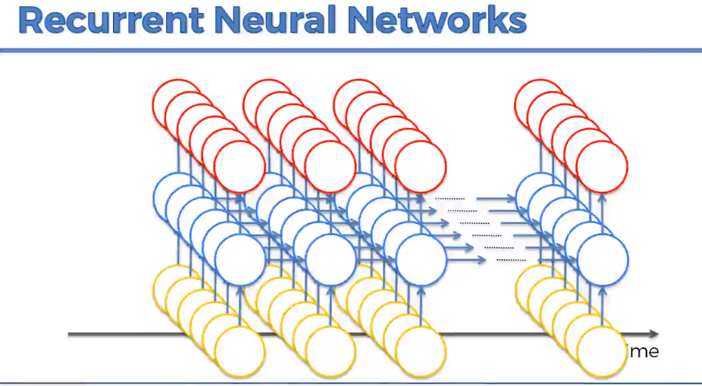

Neurons are connected to themselves through time.

To build subtitles, we use RNN

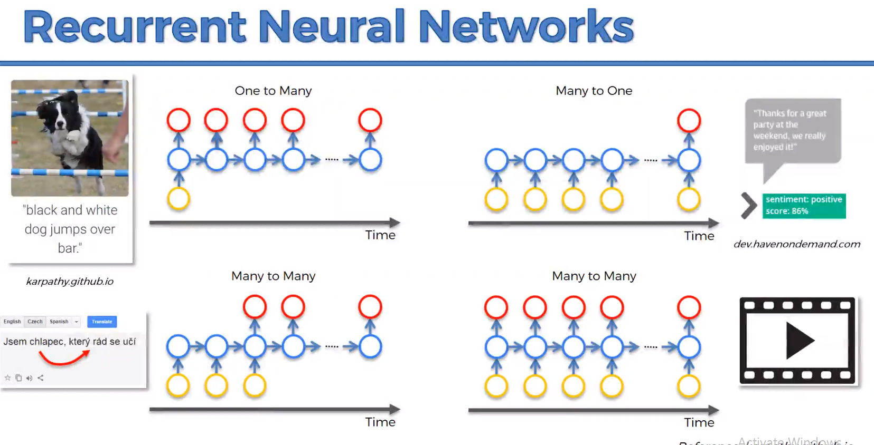



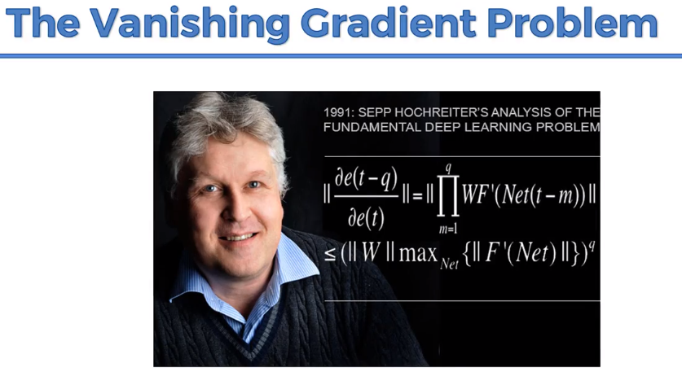

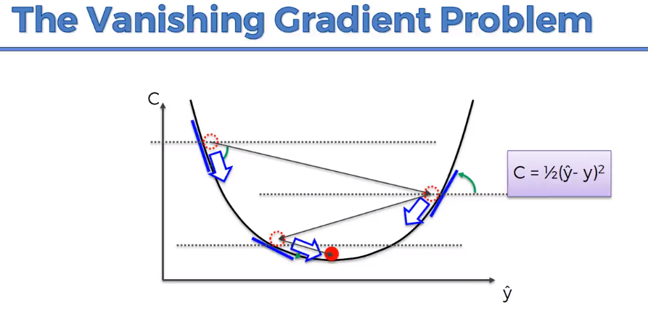

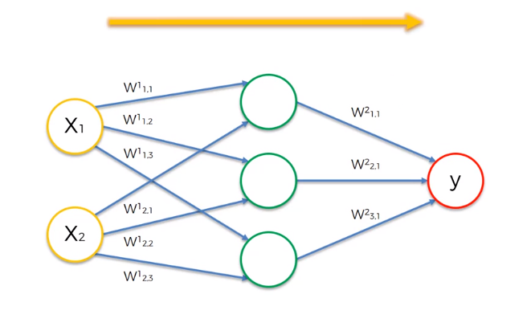

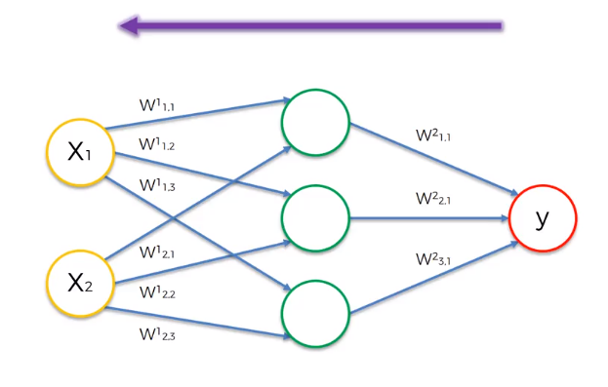

RNN:

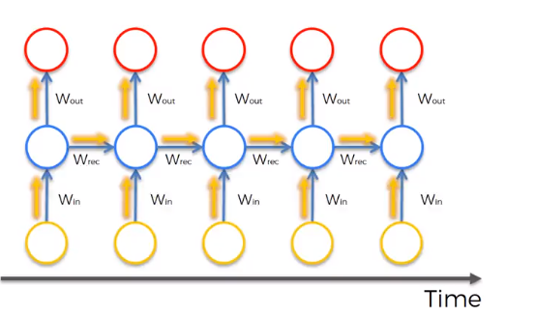

**Problem: backward propagation to update**

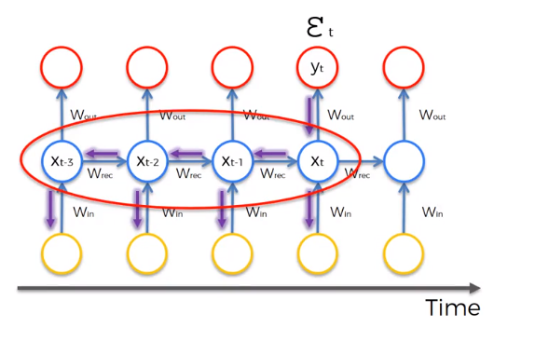

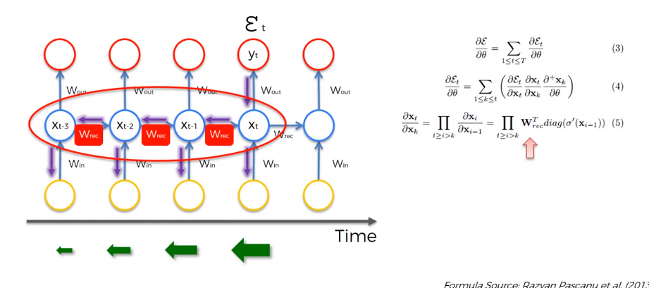

The gradient goes back in the network, it reduces the gradient.

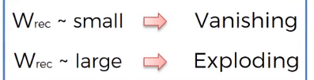

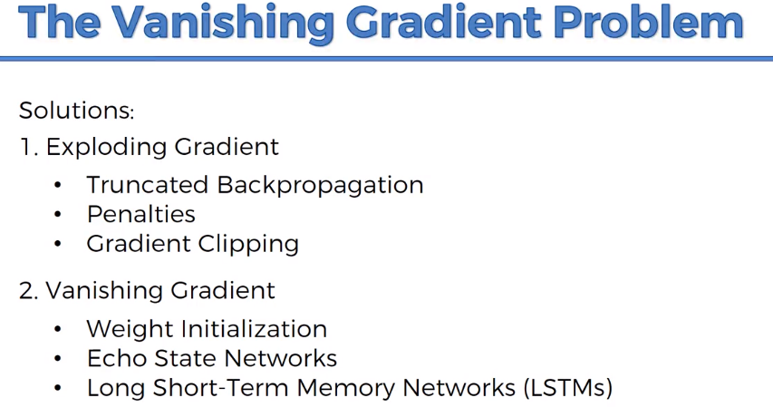

https://dl.acm.org/citation.cfm?id=3043083

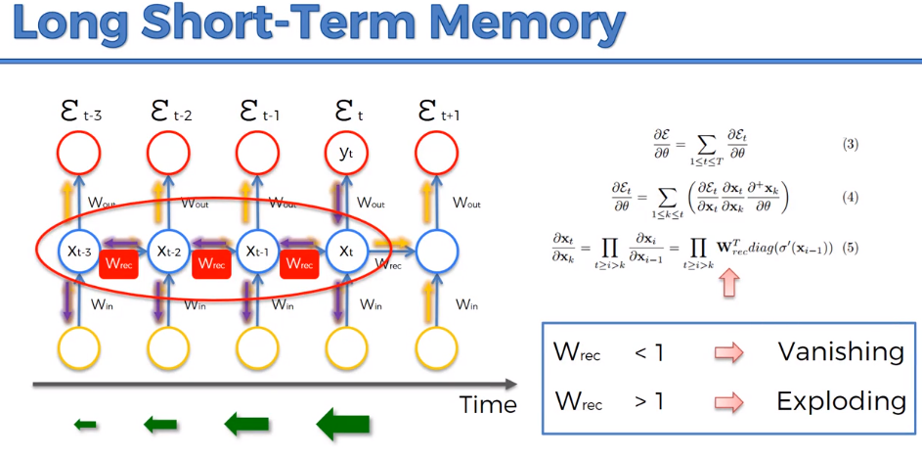

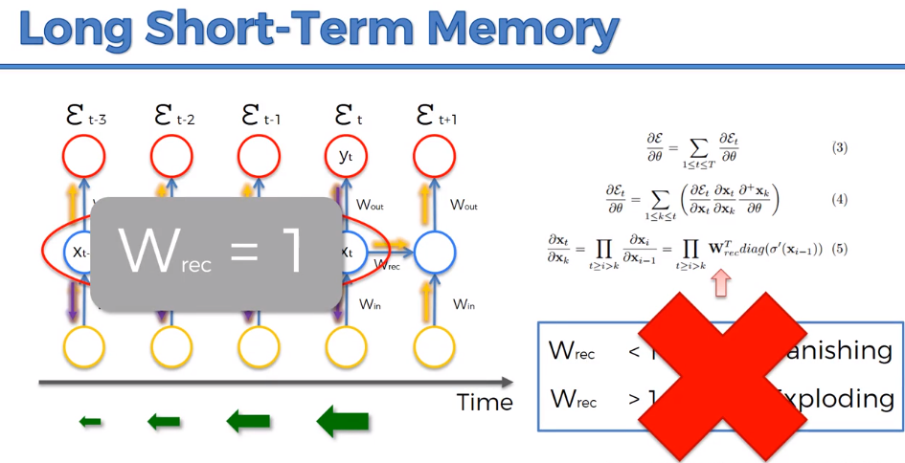

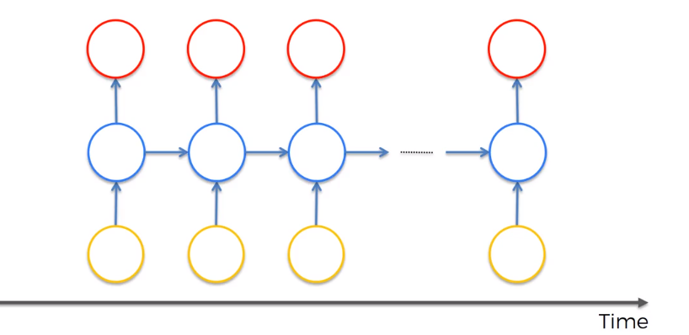

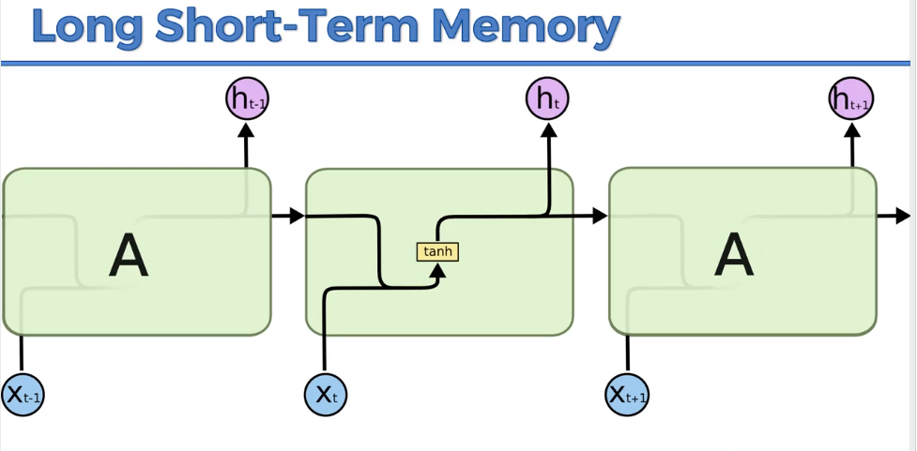

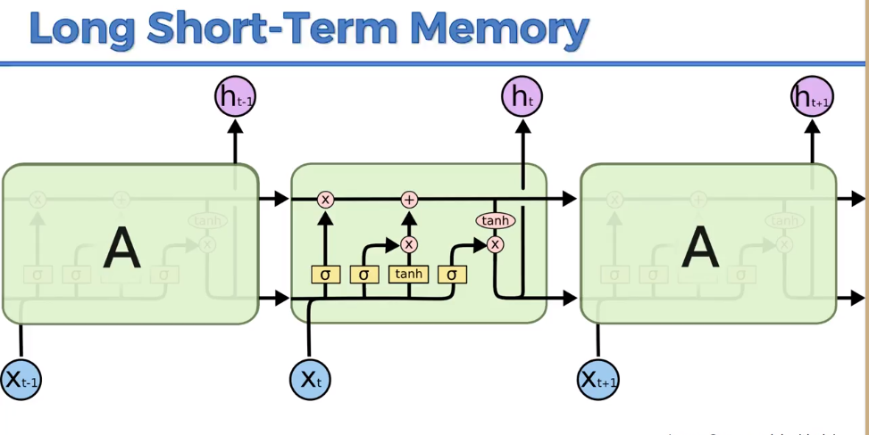

LSTE has memory pipeline flows through time.

C🡪 Memory

h🡪 o/p

X🡪i/p

X,c,h are vectors ie has multiple value and layers

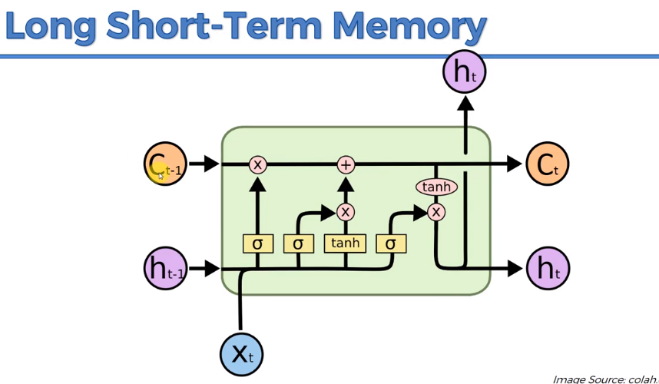

**Important Reference: http://colah.github.io/posts/2015-08-Understanding-LSTMs/**

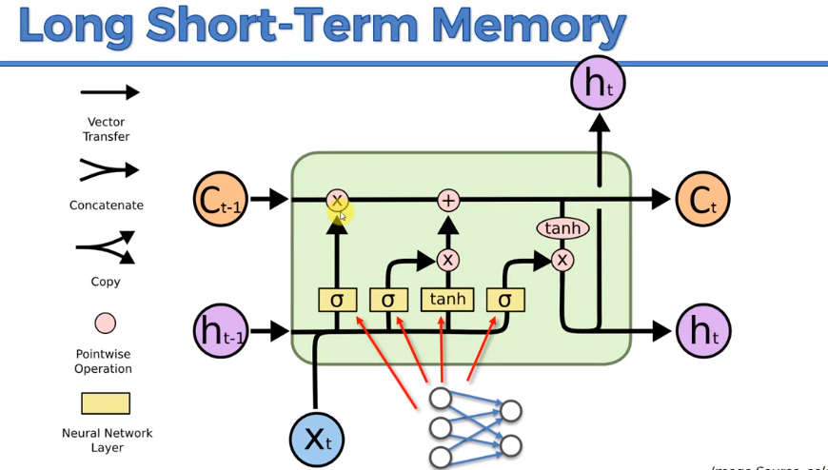

**S1:**

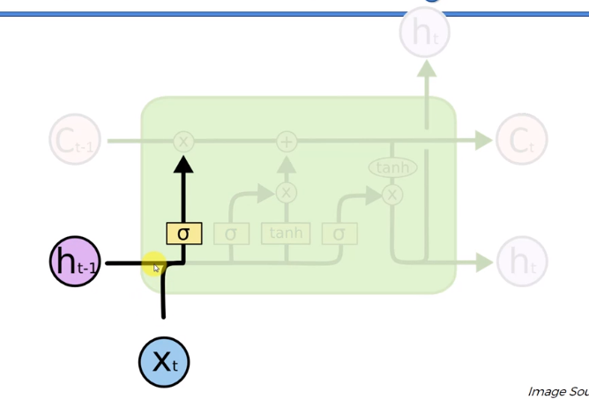

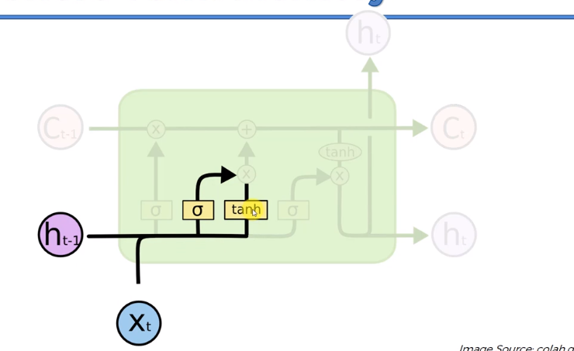

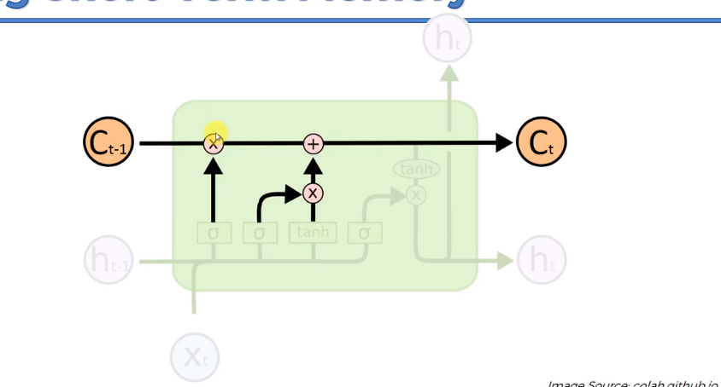

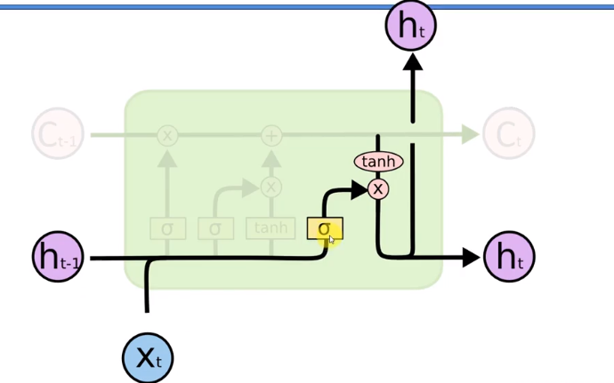



How RNN reads a paragraph. It uses the memory

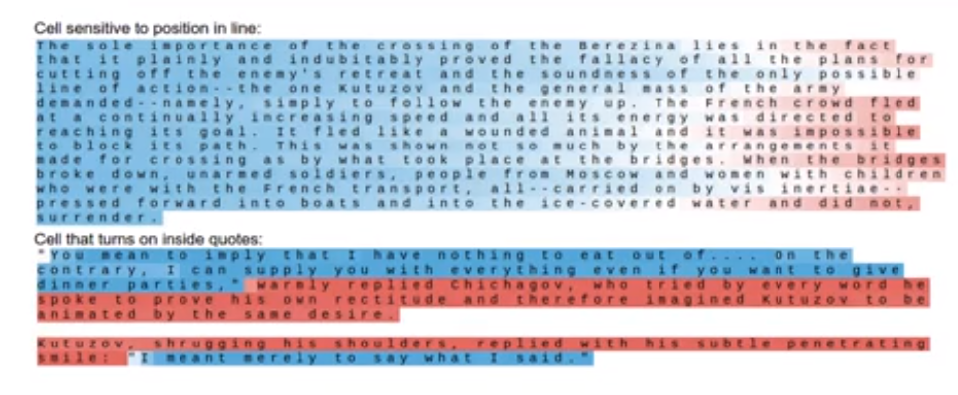

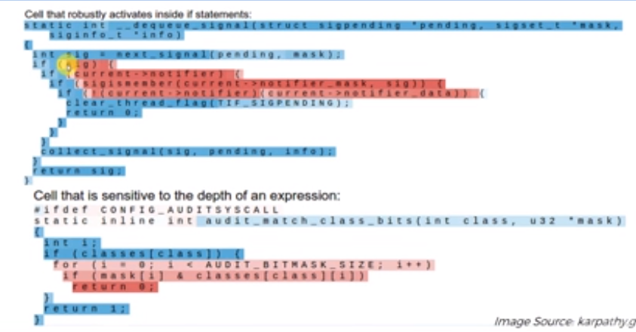

**Green🡪 active**

**Blue🡪 not active**

**Light red🡪unlikely prediction**

**Dark red🡪likely prediction** 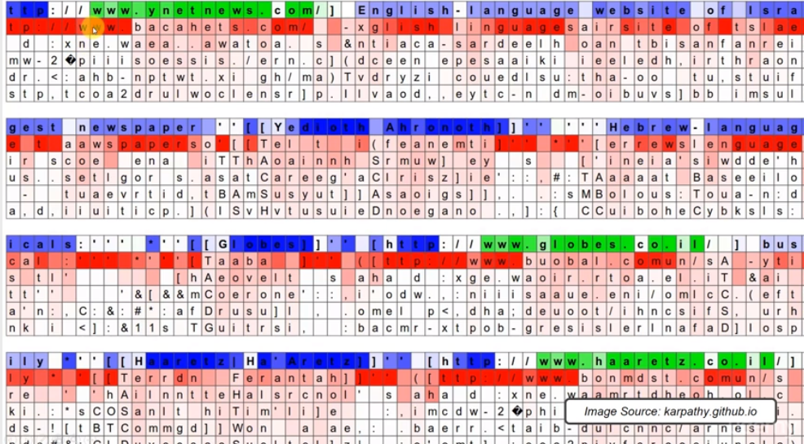

Based on one or 2 letters, it is predicting the word.

